“IoT-based Intelligent Energy Efficiency Management System for Smart Industries (IoT-IEEMS)”

Clement Regis TUYISHIME1, Frederick NZANYWAYINGOMA2, Omar GATERA3

African Center of Excellence in Internet of Things (ACEIoT)

College of Science and Technology (CST)

University of Rwanda (UR)

Kigali, Rwanda

1, 3 School of Engineering, 2School of ICT

1clementregis9478@@gmail.com, 2nzanywafr@gmail.com, 3ogatera@gmail.com

**Abstract**—The internet of things (IoT) has been useful in different sectors and attracted more attention in researches. IoT technologies are mainly used to enable the physical objects to collect and exchange data by using wireless network protocols. Moreover, IoT technologies have been applied in different applications including energy control and monitoring. However, energy efficiency has been the main challenge in industries, when comparing the energy consumption, production and cost. Therefore, this research project will develop an IoT-based intelligent Energy Efficiency Management System to enhance energy efficiency in current industries and the Industry 4.0 by focusing on agro-processing industries in Rwanda.

**Index Terms**—Internet of Things, IoT-IEEMS, Sensors, Industry 4.0, and Wireless sensor Networks

1. **INTRODUCTION**

A wide variety of modern technologies such as communication systems (e.g.5G), intelligent robots, and the Internet of Things (IoT) are expected to empower the fourth industrial revolution [5].IoT interconnects a number of devices, people, data, and processes, by allowing them to communicate with each other seamlessly. Hence, IoT can help improving different processes to be more quantifiable and measurable by collecting and processing large amount of data [6]. IoT can potentially enhance the quality of life in different areas including medical services, smart cities, construction industry, agriculture, water management, and the energy sector [7].This is enabled by providing an increased automated decision-making in real-time and facilitating tools for optimizing such decisions. Intelligent energy efficiency system can compromise the control units and the sensor networks on gathering high amount of data and analyzed through using platform by comparing the described data with the accurate data that considered in industries to enhance energy in agro-processing industries. On the other, side the installation of the different sensors in agro-processing industry required is expensive on equipment cabling and sometimes is very hard to install the industrial energy management system. Although, this IoT-IEEMS can, help to reduce the installation labor as well as the cost for the energy management system in agro processing industries [6].

Another technology used in agro-processing industries is Wireless sensor network. Wireless sensor networks (WSNs), is essentially used on the interconnected smart sensors that monitoring, sensing and control the environmental conditions. Its applications are including the industrial monitoring, traffic monitoring and environmental monitoring.RFID and WSNs are mainly used for the progress of the Internet of Things (IoT) [8]. The application of the internet, system becomes secured, live data monitoring can be applied, and it is possible to use IoT system in the industries processing and manufacturing of agriculture products. For the previous generation of industries, industry was monitored manually, but now the industry has the intellectual way to processing agro-products without any human intervention [9].

WSN used to tackle the issue of energy in industries and has many applications, where WSN are formed by huge interconnections of sensors to detect the physical things such as humidity,temperature, noise frequency, illuminance and energy consumptions [11] [12]. WSN is designed to be used for more application in order to satisfy the required standard on differentiating one application to another. Great effort have been put to get better of energy saving and energy problem. The potential application are applied in agro-processing industry, where WSN and energy management system are majority important that has an effect in that domain, thus, we need more strategies and standardization policies to enhance energy in industrial sector as one of the main challenge in agro-processing industry [12].

The industry parameters like temperature, humidity, energy consumption and heating of different equipment’s are managed by reading the data from the sensors employed and located on the typical equipment in the industry. Using IoT-IEEMS is environmentally flexible and cost saving for the agro-processing industries .The fig.1 show the various input of sensors with the meters and power due to solar or any other form that generate power to the equipment inside the industry, the controller will act to record and monitor the data described by each sensors [10].

Here below is the description of energy management system in figure:

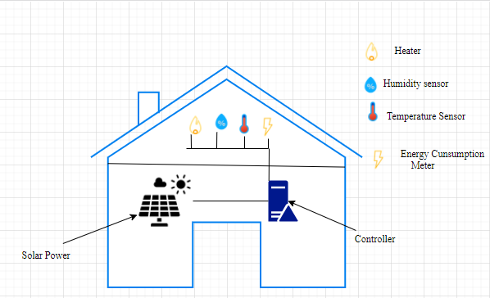

Fig. 1. An overview of energy management system

In this research, IoT-based intelligent energy efficiency management system for smart industries (IoT-IEEMS); will be developed with the purpose to enhance energy in smart industries and with a focus on agro-processing industries. A typical setup of such industries will be determined and simulated to observe certain important parameters that affect the energy efficiency in industries such as energy consumption, temperature, humidity, noise emission frequency, and illumination. IoT-IEEMS will be developed, used to analyze the data and to help an operator to act accordingly on performing the required action. This will help the industries to utilize the energy efficiently, to produce in terms quality and quantity, to reduce the cost of production and thus to increase the benefits as well as to enhance the global economy [13].

The proposed prototype for smart industries is consisting of Node MCU-ESP8266 as a microcontroller of the input values from the different sensors, Wi-Fi shield, modules such as temperature sensor and humidity Sensor. The parameters values will vary depends on the conditions of the Equipment usage i.e. lamp light, Motor frequency. This system will give the results on the plots of graphs based on the parameters of the sensed values of data and uploading in cloud server through MQTT protocol for the visualization of data to the Node-RED platform and make a notification to the industries operators through using email on a computer. The way this system achieving the energy efficiency based on the equipment’s, i.e. Motors, Lamps, ventilators and other typical equipment across the environmental conditions. This gives the operator skills to act accordingly on energy consumption of the appliances at the industries in actual time [14].

**II. MOTIVATION OF IOT-IEEMS**

The energy demand globally are characterized by increasing 2.3 percent in 2018 compared to 2017, which is the high rate increase since 2010 [15]. For the result of CO2 emission due to energy sector which is a record of 2018, with comparing the pre-industrial global warming is close to 1.5C, the increase of temperature level and most likely before the century of 21st century [16]. The global warming is exceed to 2C, which have a high impact on human life and on the planet in general. Different research describe that a non-fossil energy system is not possible when there is no way to enhance energy and managing the energy resources (RESs) [3], not only on the country [17], level but even also to the region [18], and globally [19].

Based on the report of the United Nation on the Sustainable Development Goals (UN-SDGs) [20], to enhance the energy is one of the main point that driving a sustainable development, which will offer the economic sustainability for the long term by reducing the energy generation in the energy sector. For enhancing the energy efficiency in the industry 4.0, the high standard of management is required through an effective way of analysis and real-time data in the energy supply [3]. As Rwanda is now in the implementation of vision 2020 with an initiative of linking the upcoming technology with SDGs goals with aim of economic development of industries and an increase of productivity in agro-industries. IoT planned to be used on the smart industries, with considering ICT strategic plan and ICT progress. This is an assessment give away significant changes in Rwanda ICT plan and summarized with the smart Rwanda masters plan in this document [21]. The Internet of Things is a currently an industrial driving technology mainly used to conserve energy and making things to be smart. In this project, the developed system will automatically show the values to the operator, monitor the industrial applications, and help to generate intelligent decisions to the operator through using hypothesis of IoT. As IoT has given us a favorable well build system of agro-processing industrial applications and systems by using wireless communication devices and sensors. This system use IoT and wireless sensor networking in agro-processing industries to monitor and control the industry using dissimilar sensors with an IoT-IEEMS enable the operators to make decisions; this will help the agro-processing industries and governments to achieve sustainable developments based on energy efficiency in industries [9].

1. **MAIN CONTRIBUTIONS OF IOT-IEEMS**

The main motivation of this research project is to build an IoT-based intelligent energy efficiency management system (IoT-IEEMS) for the agro-processing industries 4.0 that using the sensor to capture the data and send it through using an internet. This IoT-IEEMS system will help the operator of the industries on controlling and save energy in industries using this IoT system. Currently, In Rwanda, most of the agro processing industries, the part of monitoring industrial processes use human intervention, which leads to make many errors in processing the agriculture products. As Rwanda is moving to the 4th industrial revolution, the agro processing industries are too costly and characterized by human errors. Therefore, this system are going to solve a problem of energy in industrial sector. This will be characterized in the following different ways but not limited to :

_ Low energy consumption and high-energy efficiency in Agro-processing industries.

_ Enhancement of mass production in industries.

_ Effective cost of production.

_ Improvement of health and safety of staff in industries.

_ Protection of the environment.

_ Facilitating industry maintenance and operations with real time notification.

_ Implementation of the fourth industrial revolution technologies in industries.

_ Contribution to stable development and sustainable economy of countries based on Internet of thing technology.

_ Contribution to ICT-based economy application in agro-processing industries in Rwanda.

_ Reduction of waste and increase of profitability in the agro processing industries.

1. **PROBLEM STATEMENT**
2. Insufficiency of Energy efficiency in agro-processing industries.

Rwanda‘s energy balance shows that about the overall of energy consumed is house hold is biomass energy for cooking which occupy a high percentage of on energy consumption; transport, electricity generation and industrial manufacturing are based on petroleum products. In Rwanda, the total number of population had access to electricity is rapidly increase (350 000 connections) from year of 2012 to 2020 [6]. The Agro-industries in Rwanda are one of the major players in the economy sustainability of the country due to the processing of agriculture products. Here, it is noted that more than eighty percent of population in Rwanda depend their lives on agriculture activities. The use of ICT tools is very in agro-processing industries and in agriculture in general is very limited. Most of the agro-processing industries use traditional way of processing the production. Therefore, an urgent intervention is required to increase the production and profitability in this sector where efficient energy management system is a key.

1. Adoption of (IoT) based on WSNs in agro-processing industries.

Researchers and policy makers are now struggling with making rules and setting the standards for adopting in a good manner the usage of WSNs and IoT in general as the mainstream technology in the agriculture. This requires the integration of connected devices, cloud computing, big data analytics, high management of rules and policies, new applications, and services to be created in the agriculture sector and related industries which should affect positively the production, cost and economy in general.

1. **LITERATURE REVIEW**

In this section, is talking about the various existing literatures available on energy management system, gaps and the way IoT-IEEMS is going to solve the gaps.

The energy efficiency is called simply and interpreted as the reduction of the energy used on certain services or for the level of an activity, or more suitably as the art of ”Doing more with less”. The renewable energy and energy efficiency are the twin standard for sustainable energy policy [7]. The evolution of industries and internet show the various benefits of the IoT in industry 4.0 which using many procedures for connecting appliances, devices and typical industry equipment to the internet connection from anywhere in the world and combine this connectivity with our direct location, home and industries. IoT is aiming to automate actions of different domains such as industrial system, health care system, surveillance systems, telecommunication system, electrical system, transportation and many others systems [1].

_ In the first revolution, have characterized by the new resources of energy and shown by the running machines, the invention of steam power plants and the extractions of coal which is the significant development stage of this phases.

_ In the second part of revolution, is known as an electricity generation and mass production generation leads to period of rapid development of industries and is distinguished by the exhaustive iron and steel production. Many industries in this period, their assembly lines where fixed and new brand of business are established [3].

_ The third generations of industries revolutions characterized by the computer and is the phase of technologies based on communication such as: Mobile phones system, telephony system and automation in supply chain [4].

_ The fourth generation introduced by the broad variety of advanced technologies in communication system such as 5G network, the intelligent robots, and Artificial intelligence (AI) big data and IoT are anticipated to\ warrant the industries 4.0. Hence, IoT is able to improve different processes by collecting and processing a vast amount of data in order to be more quantifiable and measurable [3] [5].

IoT described as network of physical objects and software combined with embedded devices, sensors and electronics to the network connection, and that will enables objects to gathering and interchange data. A system is developed, which is automatically monitor the industries operation and application to generate alerts and alarms and take smart decisions with conceptualization of internet of things [27].

In one of the research reported, Vignesh and his team develop an IoT based smart energy management system based on temperature, which is automated, and humidity monitoring by using raspberry PI as a control system [28]. Where it receives the values sensed and sent to internet connection. This research accomplished by smart home monitoring and control [29] by using user friendly GUI that has been developed to be accessed anywhere by using internet connection. System measure the temperature and current voltage of socket, and each room in house will be monitored with regard to the threshold transgression before fire or circuit breaker happen [30] [28]. In addition, in this research they deal with controlling light system in the schoolroom for the purpose of energy efficiency through using command on the application on android phone by using Bluetooth, which help to manage the energy level of appliances [31]. The demand of electricity in this research has been predicted based on the mechanism of

Energy demand [32].

The related research discusses other methodology regarding the energy efficiency with intelligent management system using different methods and varying applications. It is also

included the theory and information on enhancing energy based on the parameters in agro-processing industry and the required standardization and methodology of energy efficiency in industries.

1. **IOT-BASED INTELLIGENT ENERGY EFFICIENCY MANAGEMENT SYSTEM (IOT-IEEMS)**

The existing Smart energy management system are dealing with controlling the appliances and managing the risk for electrical faults. There is no any research project system has been developed in relation to energy efficiency management system in agro-processing industries with using Node-RED by monitoring, evaluating data and notifying the energy consumption to the operator at the industry who are in charge to monitor the environmental conditions and controlling the appliance energy usage accordingly.

With the upcoming of Internet of Things, known as machine-to machine communication, the developed and IoT-IEEMS use different Sensors like: Temperature and humidity sensor to capture the data. It is based on the parameters like frequency and energy consumption in order to send data to the microcontroller (Node MCUESP8266), programmed to compare the sensed data with the real value used to enhance energy efficiency on different equipment’s at the agro-processing industries.

This IoT system help to control the current situation of managing energy used with different appliances at the industry and system evaluate data sensed by using data analysis on the Monitor for the industry operator through using a visualization platform of Node-RED [22].

1. **Use case diagram for IoT-IEEMS**

The use case diagram show the representation of IoT-IEEMS and the operator interaction with using different cases such as: Sensors, data collection, data notification, operator

Decision, data analysis, records, and the visualization of data.

**1. Sensor:** IoT-IEEMS are employed in the agro processing industry to captures some parameters like temperature and humidity for the specific purpose of collecting data.

**2. Data collection**: Describe the way the sensors in IoT-IEEMS will capture information from the physical things with using IoT concepts.

**3. Data Notification**: The data will be published and subscribed to MQTT. The designed dashboard of IoT-IEEMS will receive a notification on the change happen when data are collected with the sensors.

**4. Data visualization:** The description of data will be shown by using a Node-RED dashboard through using MQTT paradigm and will help an operator to act accordingly based on values described on the dashboard.

**5. Data analysis and Records:** On the dashboard, the operators is able make analysis and view records on useful information of data by inspecting, transforming and take decision accordingly to enhance energy efficiency in the industries.

**6. Operator decisions:** Operator decision will depend on the visualization of data, an operator will act by making conclusions and a required action on different equipment’s at the agro processing industry.

1. **System Architecture of IoT-IEEMS**

The typical equipment in agro-processing industry include but not limited to lamps, ventilators, crushing machines, drying machines, cooling machines, packaging machines among others. All these machines and other appliances consume the energy; dissipate the temperature, humidity and noise. Power frequency is the conventional value used in the electricity supply; this value should be stable for the good operation of appliances or equipment. Illumination is another important parameter in closed environment; this should be in acceptable range for the good working environment, health and safety of people. All these parameters should be observed and well regulated or controlled for the overall efficiency of the industry.

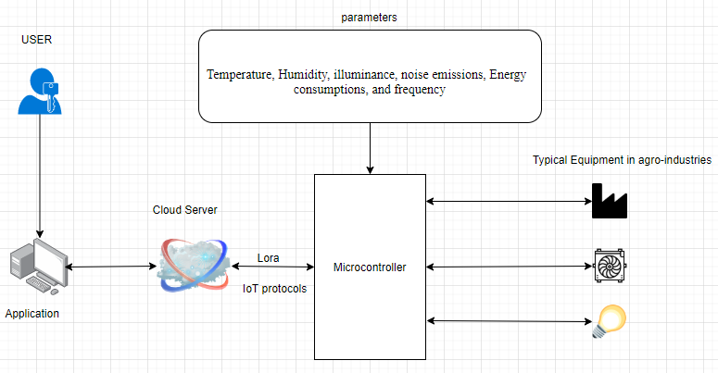

Fig. 4. System architecture of IoT-IEEMS

In this research, these parameters will generated within a specific period and analyzed using a new developed system; the results will be displayed together with the status of equipment or environment in general. The system will generate values according to the values obtained through the survey in industries for typical equipment and standards values available in national or international standards. The following standards will be consulted but not limited to:

_ RS ISO 50001: Energy management system [23].

_ RS ISO 14001: Environment management system-Requirement with guidance for use.

_ RS 237: Acoustics – Noise Pollution – Tolerance limits [24].

The visualization of data make a decision to an operator to act accordingly may be ”normal environment temperature, high temperature in production room or on crushing machine, normal noise emission or high noise emission in a certain room/place, normal energy consumption or high energy consumption on a particular machine/equipment, normal frequency or unstable frequency”. Two of these parameters mentioned above, will be generated periodically on dashboard and will help the operators to adjust the machines, replace the equipment or to perform any other maintenance activity.

1. **System flow chart of IoT-IEEMS**

The design of working principle of IoT-IEEMS is summarized by the system flow chart described below, which is composed by these steps:

1. Starting the system

2. The sensing of parameters

3. The collection and acceptance of data

4. The notification, visualization, analysis and records of data to an industry operator

5. The system repair

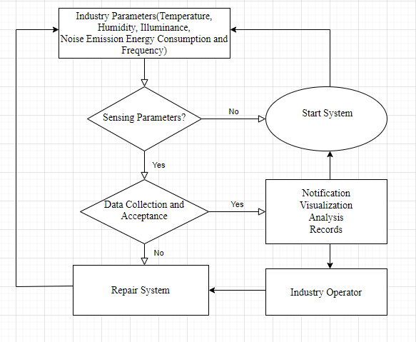

Fig. 5. Flow chart of IoT-IEEMS

**VII. IMPLEMENTATIONS, RESULTS AND ANALYSIS**

The main results of this project is going to be explained in the figures below, start from hardware prototype and steps for getting real time data. This system of IoT-IEEMS can be used in the agro processing industries. Where the Microcontroller of Node MCU-ESP8266 used to control the whole system by receiving data from sensors that employed at the industry, and display those information directly to the Node-RED visualization platform through using Internet Protocol of MQTT.

1. **Prototype of IoT-IEEMS**



Fig. 6. IoT-IEEMS prototype

Hardware prototype has composed with the interconnection of sensor (Temperature and Humidity sensor) with using jumper wires using breadboard for making connection. Data processed are made by using Node MCU (ESP 8266) as a Wi-Fi microcontroller, which is flexible to send the captured data on the cloud and allow the system to interact with cloud application through using remote end users.

1. **Node-RED Dashboard**

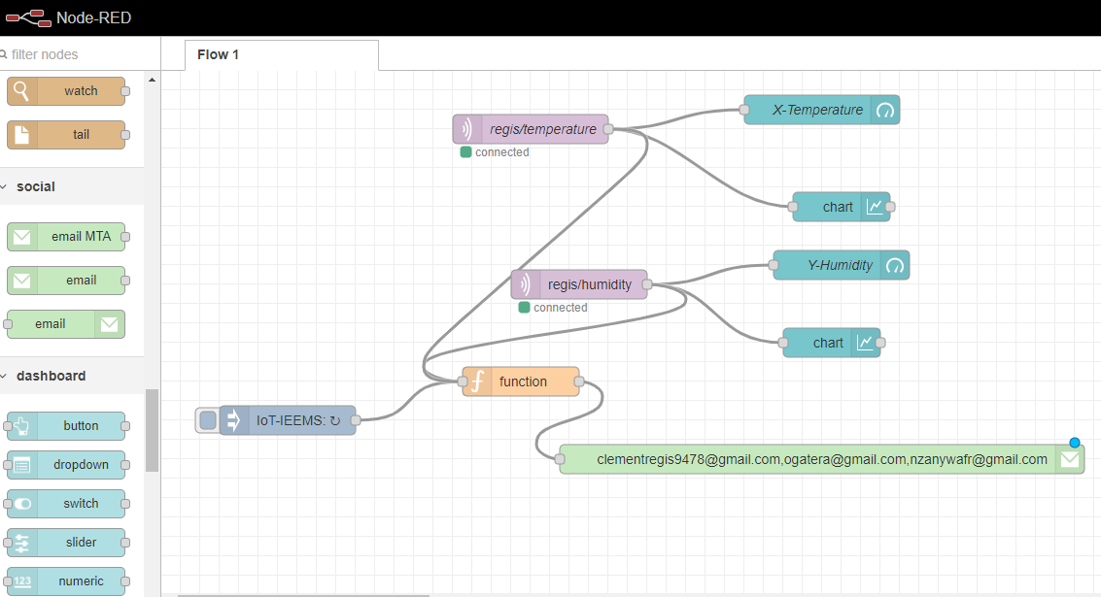

Fig. 7. Node RED connection flow chart by using temperature and Humidity sensors of IoT-IEEMS

Shows the dashboard of Node-RED known as Node panel for editing, Node-RED designed as an open source for the integration of hardware devices with using APIs [33]. Node-RED described above is the interface that contain connection of regis/temperature that describe the temperature captured by temperature sensor; data will be read in the next figure by flow panel using x-temperature. In addition, regis/humidity received the data captured by humidity sensor, and will be read on the flow panel with y-humidity. As described the palette of notification is injected by the function palette, which is containing the calling function to send an email to the three subscribers through using their personal emails.

1. **Graphs**

In figure 8, the data captured by sensor are flowing by using this IoT real time data acquisition using MQTT protocol. For regis/temperature is recording the values of temperature from sensor and for regis/humidity is recording the values of humidity capture by sensor and all those two are used as to subscribe to the MQTT client (Node MCU-ESP 8266) and publishing data to the MQTT Client of Node-RED. The temperature received by using regis/ temperature is 24 degree Celsius and Humidity read by regis/humidity is 55 percent.

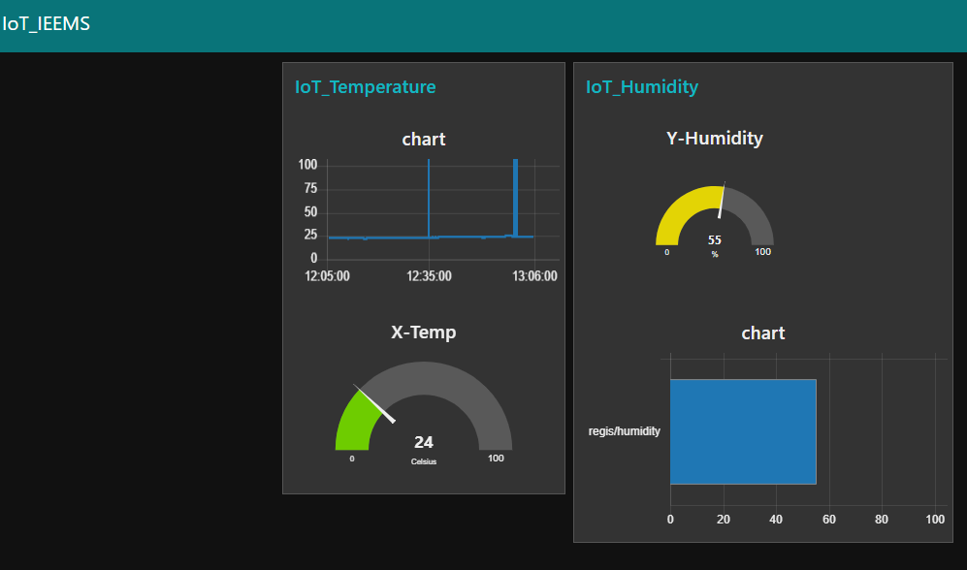

Fig. 8. Node Red data visualization in Graphs

The node flow panel monitor directly the data on the visualization platform. The industry operators can access the platform through Graphic User Interface (GUI), they can intervene based on the real time data of humidity and temperature inside the industry and for any typical equipment, i.e. Motor, Lamp ...”. An operator can intervene quickly for enhancing energy consumed at the industry for the problem of higher humidity and temperature or very lower of temperature and humidity. The values of temperature is varying by using the gauge and graphs that show the way the temperature changed directly with respect to time and it’s the same for the humidity is varying based on the time.

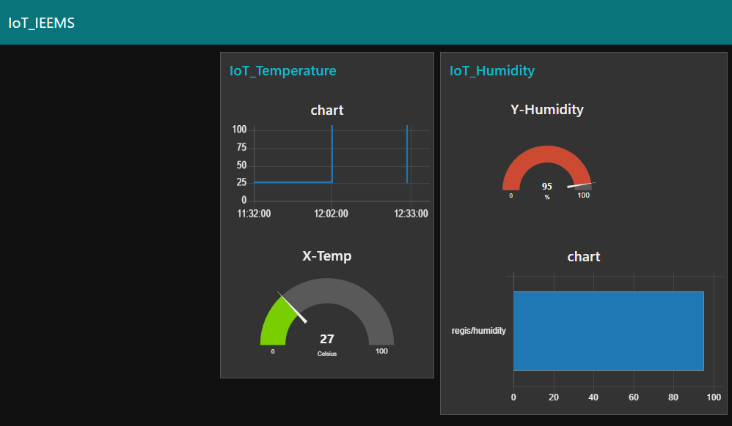

Fig. 9. Node Red data change visualization in graphs.

Figure 9, Show the change that happen after the rate of variation is based on temperature and humidity. In agro-processing industries, when there is change made maybe based on the equipment or the environmental factor that will affect the way energy consumed to certain equipment. Here it is noted that the temperature going up to 27 degree Celsius and humidity on 95 percent, that show the way humidity is very higher may cause problems based on the working condition of equipment at the industry. The visualization of data will enhance the way data received and increased the productivity in agro-processing industry through using IoT platform to receive data and operator act accordingly in direct time.

**VIII. CONCLUSION AND FUTURE WORKS**

IoT-IEEMS would provide a reliable way of managing energy in industry 4.0 where we can access and be notified by live data using an IoT platform to visualize the data and system will help to make quick decision based on the industrial parameters of temperature and humidity. The IoT-IEEMS is shown that the visualization of live data on dashboard or any other graphic user interface (GUI) used to describe the role of enhancing energy efficiency Industry 4.0. It is most important to help the agro-processing industries operators to act accordingly in the industries based on the direct monitoring of data flow from the different sensor employed at the industry; the system implemented is limited with the prototype with considering only two parameters and intelligent system based on sending notification through an email to an operator. The planning, design, and execution of this project of IoT-IEEMS in agro-processing industries in Rwanda, have really been possible.

The configuration of the various parameters based on temperature, humidity, noise emission, illuminance and power consumption with considering other parameters can be considered in the future for the implementation of the project in agro-industries, where all parameters will be monitored in real time and this project took a lot of courage, technical and theoretical initiative of the engineering practice to be deployed in industry 4.0. In future, we propose an addition of real time description and alert of data to an operator with considering all parameters used in the agro-industry. The actuator will be considered also to be used to control directly the appliances at the industry and this proposed system can be improved to use the fetched real time data from sensors for increasing the accuracy on the operator’s decisions.

**ACKNOWLEDGMENT**

The authors are addressing many thanks to the African Center of excellence in Internet of Things (ACE-IoT) for their valuable support to conduct and publish this research.

**REFERENCES**

[1] Al-Ali, Abdul-Rahman, et al. ”A smart home energy management system using IoT and big data analytics approach.” IEEE Transactions on Consumer Electronics 63.4 (2017): 426-434.

[2] Sekki, Tiina, Miimu Airaksinen, and Arto Saari. ”Effect of energy measures on the values of energy efficiency indicators in Finnish daycare and school buildings.” Energy and Buildings 139 (2017): 124-132.

[3] Hossein Motlagh, Naser, et al. ”Internet of Things (IoT) and the energy sector.” Energies 13.2 (2020): 494.

[4] M. C. JENSEN, “The Modern Industrial Revolution, Exit, and the Failure of Internal Control Systems,” J. Finance, vol. 48, no. 3, pp. 831–880, 1993, doi: 10.1111/j.1540 6261.1993.tb04022.x.

[5] Datta, Soumya Kanti, and Christian Bonnet. ”MEC and IoT Based Automatic Agent Reconfiguration in Industry 4.0.” 2018 IEEE International Conference on Advanced Networks and Telecommunications Systems (ANTS). IEEE, 2018.

[6] Shrouf, Fadi, Joaquin Ordieres, and Giovanni Miragliotta. ”Smart factories in Industry 4.0: A review of the concept and of energy management approached in production based on the Internet of Things paradigm.” 2014 IEEE international conference on industrial engineering and engineering management. IEEE, 2014.

[7] Bandyopadhya, D., and J. Sen. ”Internet of things: Applications and

challenges in technology and standardization.” Wireless Personal Communications 58.1 (2011): 49-69.

[8] Khajenasiri, Iman, et al. ”A review on Internet of Things solutions for intelligent energy control in buildings for smart city applications.” Energy Procedia 111 (2017): 770-779.

[9] Haldikar, Aishwarya, et al. ”IOT Based Industrial Management.”

[10] Karim, Ahmad. IoT based monitoring and control for energy management system. MS thesis. 2018.

[11] Alawad, Hamad Ali H., and Sakdirat Kaewunruen. ”Wireless sensor networks.” (2003).

[12] Aponte-Luis, Juan, et al. ”An efficient wireless sensor network for industrial monitoring and control.” Sensors 18.1 (2018): 182.

[13] Dhobale, Kiran M., et al. ”IOT based Smart Water Supply management System.” International Journal of Advanced Research in Computer and Communication Engineering (2017).

[14] Mani, Vignesh, and Gunasekhar Abhilasha. ”Iot based smart energy management system.” International Journal of Applied Engineering Research 12.16 (2017): 5455-5462.

[15] Papadopoulou, M. P., et al. ”Assessing climate change impacts of Greek energy mix based on LCA.”

[16] Leung, Jonathan YS, Bayden D. Russell, and Sean D. Connell. ”Adaptive responses of marine gastropods to heatwaves.” One Earth 1.3 (2019): 374-381.

[17] Zakeri, Behnam, Sanna Syri, and Samuli Rinne. ”Higher renewable energy integration into the existing energy system of Finland–Is there any maximum limit?.” Energy 92 (2015): 244259.

[18] Mekhilef, Saad, Rahman Saidur, and Masoud Kamalisarvestani. ”Effect of dust, humidity and air velocity on efficiency of photovoltaic cells.” Renewable and sustainable energy reviews 16.5 (2012): 2920-2925.

[19] Grubler, Arnulf, et al. ”A low energy demand scenario for meeting the 1.5 C target and sustainable development goals without negative emission technologies.” Nature energy 3.6 (2018): 515-527.

[20] Boluk, Karla A., Christina T. Cavaliere, and Freya Higgins-Desbiolles. ”A critical framework for interrogating the United Nations Sustainable Development Goals 2030 Agenda in tourism.” (2019): 847-864.

[21] Crawford, Beverly. Power and German foreign policy: embedded hegemony in Europe. Springer, 2007.

[22] Leki´c, M., Gardaˇsevi´c, G. (2018, March). IoT sensor integration to Node-RED platform. In 2018 17th International Symposium INFOTEHJAHORINA (INFOTEH) (pp. 1-5). IEEE.

[23] Eccleston, C. H., March, F., Cohen, T. (2011). Inside energy: Developing and managing an ISO 50001 energy management system. CRC Press.

[24] “STANDARD,” 2020.

[25] Eccleston, C. H., March, F., Cohen, T. (2011). Inside energy: Developing and managing an ISO 50001 energy management system. CRC Press.

[26] F. Bua and J. Peronnet, “Advisory Committee of Energy Efficiency,” 2020.

[27] Haldikar, A., Lalwani, P., Pandey, S., Chitari, A. IOT Based Industrial Management.

[28] Dhobale, K. M., Gorgile, S. P., Gunjal, P. J., Hirve, K. A., Mande, U. A. (2017). IOT based Smart Water Supply management System. International Journal of Advanced Research in Computer and Communication Engineering.

[29] Jie, Y., Pei, J. Y., Jun, L., Yun, G., Wei, X. (2013, June). Smart home system based on iot technologies. In 2013 International Conference on Computational and Information Sciences (pp. 1789-1791). IEEE.

[30] Ghayvat, H., Mukhopadhyay, S., Gui, X., Suryadevara, N. (2015). WSNand IOT-based smart homes and their extension to smart buildings. Sensors, 15(5), 10350-10379.

[31] Tonage, S., Yemul, S., Jare, R., Patki, V. (2018). IoT based home automation system using NodeMCU ESP8266 module. International Journal of Advance Research and Development, 3, 332-334.

[32] Kakkar, S., Verma, R. (2018). IOT based Home Automation using Raspberry pi.

[33] Leki´c, M.,Gardaˇsevi´c, G. (2018, March). IoT sensor integration to Node-RED platform. In 2018 17th International Symposium INFOTEHJAHORINA (INFOTEH) (pp. 1-5). IEEE.